

# Opel Big Button X 4G

## Type of device: Mobile

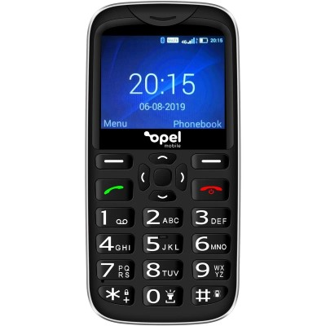

Actual Display Size : 2.31"

Button Type : Physical Keypad

Network Capability : 3G,4G

Average Price : $99 as of 06 03 2020

Other : 0

## Accessibility Features:

### Cognitive

* GPS
* Simple Instructions
* Simple Reminders

Simplify Display

### Hearing Impairment and Deaf

* Bluetooth or Wi-Fi
* Text Messaging/SMS
* Vibrating Alerts - Adjustable

Visual Alerts - Incoming Calls

### Vision

* Battery Alert - Audible
* Bluetooth or Wi-Fi
* Brightness Adjustable
* Key Marker – Raised '5'
* Key Numbers - Standard Layout
* Key Press - Vibration or Click

Power Cue

### Speech

* Bluetooth or Wi-Fi
* Messaging Options - Email
* Messaging Options - MMS

Predictive Text

### Physical

* Bluetooth or Wi-Fi
* Flat Back for Table Top Operation
* Guarded/Recessed Keys
* Physical Dialling Keys
* Predictive Text

Speaker-phone option

## How and where to get it from?

You can buy this phone from [The Good Guys](https://www.thegoodguys.com.au/opel-mobile-bigbutton-x-4g-ombbx19b?istCompanyId=3bea4a6c-bec2-47ac-ad52-cc426c68327c&istFeedId=e8d5c196-db26-43bb-982c-cfe72bb147d0&istItemId=iiilaattx&istBid=t&gclid=CjwKCAiA44LzBRB-EiwA-jJipPUYToGYKFeakpp0RiENlxOmk2MN4OZHSRwX6tYm20gekyQofhcOXxoCa2IQAvD_BwE&gclsrc=aw.ds), and other retailers.

## More information is available on:

[Opel Big Button X 4G PDF User Manual](https://www.opelmobile.com.au/wp-content/uploads/2019/10/BigButton-X-A4-v2.pdf)

[Opel Big Button X 4G Webpage](https://www.opelmobile.com.au/our-phones/bigbutton-x/)